Instructions for using the Car Show Display Stand
www.streetrod101.com

Parts Identification
The car show display stand parts are shown in Figure 1 below. They include the base plate, the lower post, the upper post, and the sign plate.
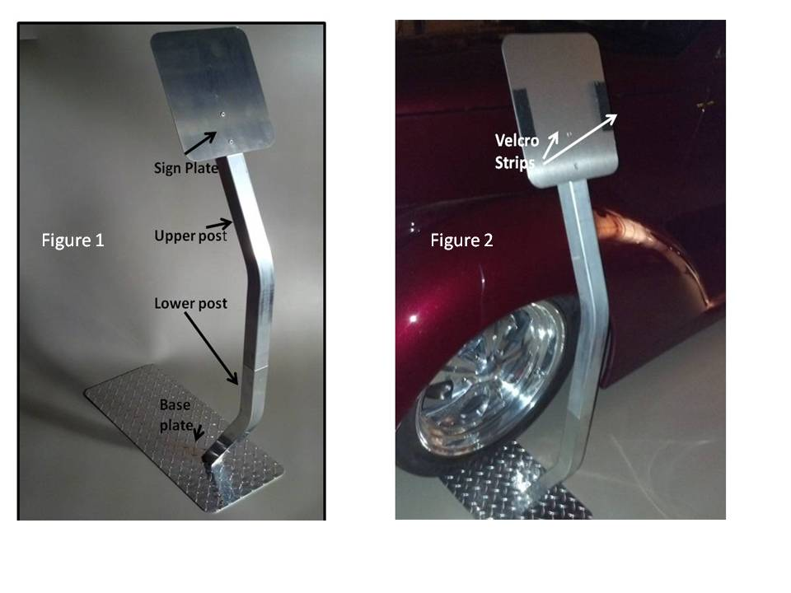

Placing Your Sign On The Sign Plate
To begin, place two Velcro strips on each side of the front of the sign plate as shown in Figure 2 above. Use the alcohol swabs (included) to clean two spots on the sign plate where the Velcro strips will be attached. Remove the plastic tape and stick one part of each Velcro strip to the sign plate. Press firmly to make sure the Velcro is sticking to the sign plate. Now place your sign in position on the sign plate and mark where the other half of the Velcro strips will be placed on the back of your sign. Remove your sign and clean the area on the back of your sign with the alcohol swab. Now stick the second half of each Velcro strip to the back of your sign. Push down firmly to stick the Velcro tape to the back of your sign.

Assembling The Car Show Display Stand
To assemble, first position the base plate in front of the car tire. Then roll or drive the car forward until the tire is centered on the base plate as shown in Figure 3and 4. Next, slip the lower post with the angled cut tube over the mating tube which is welded to the base plate. Firmly push the lower post downward and slightly toward the car wheel, making sure the top is vertical. When in this position tighten the thumb screw by hand until the lower post slack is all removed. Then slip the upper post onto the lower post. Position the upper post so that it touches and matches the lower post. Now firmly tighten by hand the middle thumb screw. Next slip the sign plate onto the upper post and firmly tighten the upper thumb screw. Now attach your sign to the Velcro strips on the sign plate as shown in Figure 4.

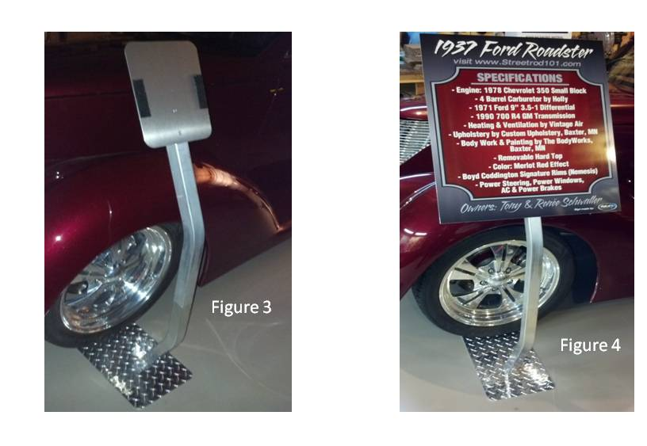
Tips:
- Always put the plastic bubble wrap sheets between the parts when in storge.
- When assembling or disassembling, hold all parts firmly, making sure they don’t touch your car.
- Tighten the thumb screws by hand only.
- Note that many customers keep the sign and sign plate together during storage and assembly.

